Student Handout
History of Arkansas’ Oil and Natural Gas Industry | Assignment 6

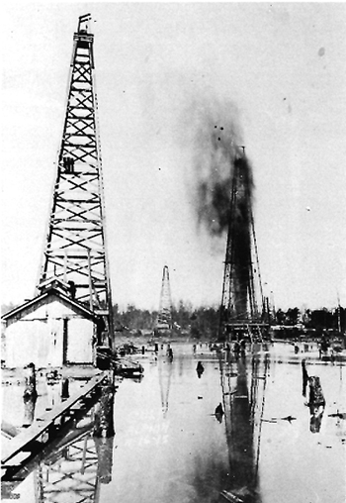
“Gusher in Smackover”

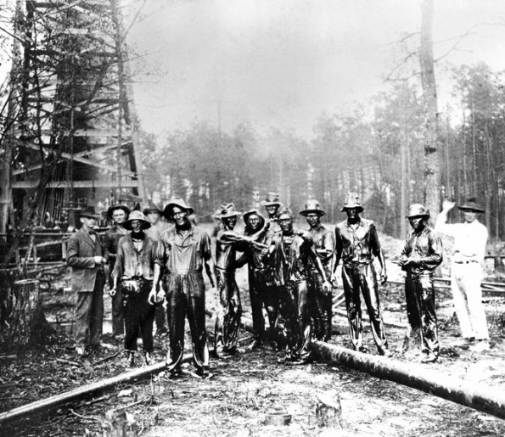
“Workers in the Smackover Oil Fields”

Student Handout #6 con’t.
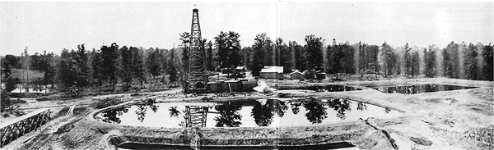
“Wooden Derrick and Oil Storage Pond”

Assignment #6 – Imagine what a typical day was like in early twentieth century Union County, Arkansas. Write a journal entry from the point of view of:
- a person living in El Dorado or Smackover when the oil strike began.
- a person coming to work in the oil fields.
- a merchant or business owner in El Dorado or Smackover.
- an oil field owner.

Include all of the vocabulary words you learned from Student Handout #1.

Enrichment:

Visit the Arkansas Museum of Natural Resources

3853 Smackover Hwy.

Smackover, AR 71762

870-725-2877

www.amnr.org/

