Exploration and Prediction Charts

Names:________________________________ _____________________________

________________________________ _____________________________

Predict: Will the Rock Drink the Water?
Rock 1
Rock 2
Rock 3
Rock 4
Rock 5
Sandstone 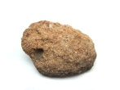
Limestone 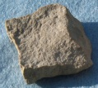
Shale 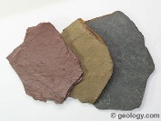
Granite 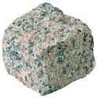

Did the Rock Drink the Water?
Rock 1
Rock 2
Rock 3
Rock 4
Rock 5
Sandstone
Limestone
Shale
Granite
Sort the rocks

1. Construct a t-chart (provided below) of foods you eat that are porous and nonporous. Non-writers may look in cooking magazines for pictures as well as Kindergarten.

Example:
Porous Nonporous

Cake Flavored gelatin
Cornbread Hard Candy
Rice Cake Chocolate Bar

T-chart

Porous Non-porous

2. Design a LaPorous Sundae using the provided ingredients:
- As you and your partners are constructing the Sundae discuss why the ingredients represent the layers.
- Think of another ingredient that would also represent each layer.

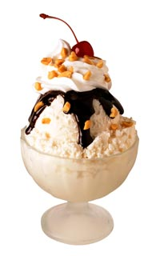
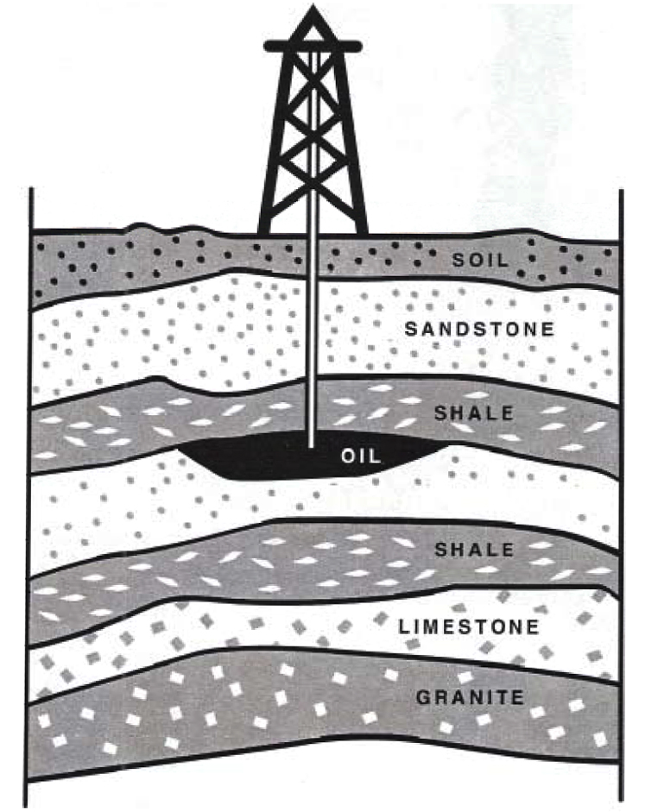
LaPorous Sundae
Fudge (squeeze)=Oil
Ice Cream=Limestone
Chocolate cream cookies= Dolomite
Crushed peanuts= Sand
Straw= Drill
Whipped Cream= Shale
Sprinkles=Gravel

