Student Handout 3

Lesson 2 – Oil and Natural Gas: Sedimentary Rocks
Lab 3 – Sedimentary Rocks

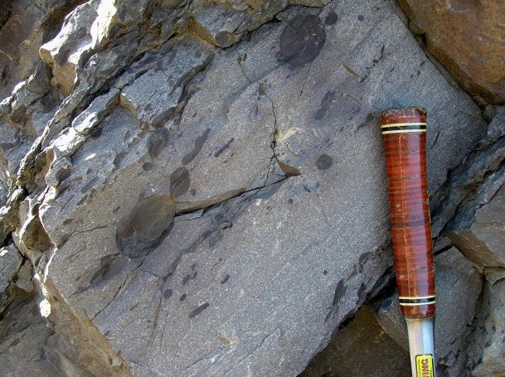
Introduction
In the two previous labs you investigated two of the processes involved in forming sedimentary rocks—deposition and cementation. Now you will have the opportunity to observe some of the types of sedimentary rocks and their characteristics. Classifying sedimentary rocks is based on how they formed. There are three categories—1)clastic, 2)chemical, and 3)organic. Clastic sedimentary rocks form from the solid particles of other rocks. Chemical sedimentary rocks form primarily from the evaporation of seawater. Organic sedimentary rocks form from the remains of living organisms.

Materials
- Collection of different types of sedimentary rocks*
- Magnifying Glass
- Dilute HCl acid
- Paper towel.
- Rock and Mineral book (see references)

Procedure
- Take the rocks out of their box/container and place them on your table.
- Record their number in the data table.
- Write a brief description, noting color, texture, hardness, and fossils.
- Place a drop of diluted HCl on each rock and note its reaction in terms of NONE, WEAK, or VIGOROUS.
- Use a paper towel to dry off any excess acid.
- Use the flow-chart on page 27 to identify the rocks.
- Use the rock reference book to determine which category it belongs to.

Results
Fill out the data table below.
Category
Name
Reaction With HCl
Description
Rock
Name
Sedimentary Rock Identification Flow-Chart

Reaction with HCl

None
Vigorous
Weak

DOLOMITE
LIMESTONE
Are the grains
visible to the
naked eye?

Are the grains larger than
2 mm?
Yes
No

Does the rock
Feel gritty?
No
Yes

No
Yes
SANDSTONE

SILTSTONE

Glassy, hard
Dull, soft
Are the grains rounded?

CHERT
No
Yes
Layered

CONGLOMERATE

Yes
No
BRECCIA

MUDSTONE
SHALE

References

Bell, Pat and Wright, David. Rocks and Minerals. Macmillan Field Guides. New York, New York. Collier Books. 1985.

Chesterman, Charles W. Field Guide to North American Rocks and Minerals. The Audubon Society. New York, New York. Alfred A Knopf. 1978.

Mottana, Annibale et al. Guide to Rocks and Minerals. New York, New York. Simon & Schuster. 1978.

Pough, Frederick H. Rocks and Minerals. Peterson Field Guides. New York, New York. Houghton Mifflin. 1996.

