Student Handout 2

Lesson 3 – Oil and Natural Gas: Deposit
Lab 2 – Understanding Viscosity

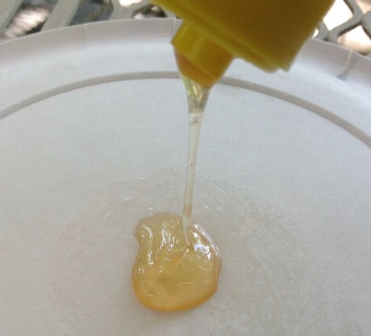
Introduction
In this simple experiment you will explore the meaning of viscosity and its importance as a physical property of fluids.

Materials
- Ruler
- Paper towel
- Wax paper
- Timer
- Permanent marker
- 3—3 oz. paper cups (1 for each liquid)
- Plastic spoon
- Vegetable oil
- Syrup
- Honey

Procedure
- Cut a sheet of wax paper about 30 centimeters long
- Use the maker to draw a line across the wax paper about 3 cm from one edge. See diagram below.

Line
Wax Paper

- Place the paper towel on your desk. This is to catch the liquids.
- Place the wax paper on the paper towel.
- Pour about a spoonful of the oil on the line you drew on the wax paper.
- Quickly raise the edge of the wax paper until vertical and time how long it takes for the oil to reach the opposite edge of the wax paper.
- Record the time in the data table.
- Repeat steps 4 through 7 for the other two liquids.

Results

Liquid | Time
Oil
Honey
Syrup

Analysis and Conclusions
- Plot a graph of the data collected in your experiment
.

Title ______________________

- Since all three materials are liquids, why do they not all flow at the same speed?

- Rank the liquids in order of decreasing speed.

- Which liquid has the lowest viscosity? The highest viscosity?

- If you were to include water in your ranking of liquids, where would it be?

- Explain how the viscosity of oil might affect how easily it can be pumped from the ground.

- Oil deposits are often associated with salt water and natural gas. What would be the correct sequence of these materials from top to bottom?

