Student Handout 5

Lesson 3 – Oil and Natural Gas: Deposits
Lab 4 – Investigating Permeability

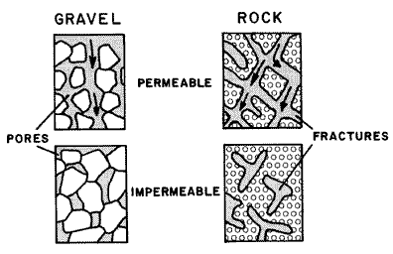
Introduction
In the previous lab you investigated a property of rocks called porosity. Permeability is a measure of how easily a liquid can flow through a material. That happens when the “pores” in a material are connected. Think of it as tunnels for liquid or gas to travel through. Look at the diagram to the right. You will test the permeability of two different materials: marbles and plastic pellets. Secondly, you will investigate the ability of different materials to hold on to some of the oil. This affects how much of the oil can actually be pumped out of the ground.
From: http://pubs.usgs.gov/of/1993/ofr93-643/

Materials:

- 3—100 ml graduated cylinders
- 2 funnels
- Timer
- Marbles
- Plastic pellets (used for flower vases)
- Ruler

Procedure:
- Measure the diameter of one of the marbles and describe its shape and texture. Record this information in the data table in the results section.
- Fill one of the funnels with marbles so that it is even with the top.
- Place the funnel with marbles on top of one of the graduated cylinders.
- Fill the other funnel with plastic pellets so that it is even with the top.
- Place the funnel with plastic pellets on top of one of the graduated cylinders.
- Fill the third graduated cylinder with 50 ml of water.
- Pour the water into the marbles slowly and evenly, start the timer as soon as you start pouring.
- Time how long it takes for the water to drain through the marbles. Stop timing when the water quits dripping.
- Record the time in the data table.
- Look at the volume of water in the graduated cylinder, this is the volume of infiltrated water; record this in the data table.
- To find the amount of stored water, subtract the infiltrated water from the original water volume. Record this in the data table.
- Repeat steps 6-11 with the plastic pellets.

Results:
Description of materials:

Material | Size | Shape | Texture
Marbles
Plastic
Pellets

Time Data:

Material | Time
Marbles
Plastic
Pellets

Volume Data:

Material | Starting  Water  Volume | Volume of  Infiltrated  Water | Volume of  Stored  Water
Marbles | 50 ml
Plastic  Pellets | 50 ml

Analysis and Conclusions:

- Make a graph of the time it took for the water to travel through the materials.

Title _____________________________

- Which material has the greatest permeability? The least? Why?

- Make a graph of the stored water volume for the materials.

- Which physical characteristic of the materials do you think has the greatest influence on permeability?

- Which of the materials holds on to the most water?

