Oil Drop Hide and Seek
Student Handout

Data Sheet

Oil Company Name:_______________________________________________

1st Search | ______________
2nd Search | ______________
3rd Search | ______________
4th Search | ______________

Graph Your Search Results

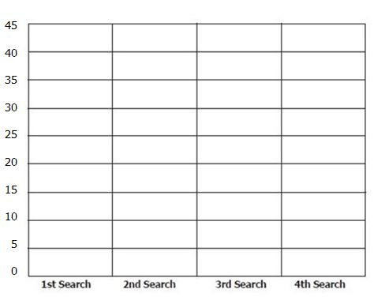

Activity Questions:

- Look at your graph. Did you find the most oil in the 1st, 2nd, 3rd or 4th search?

- What is the difference between the number of oil drops you found in your tallest graph and your shortest graph?

- Why do you think it became increasingly harder to find oil drops?

